


Data Compliance Test (DCT)
Test Cases for
Observation and Lifestyle Record

<HCP Name>

Table of Contents
1 Testing Instructions to HCPs 3
1.1 Self-Service Testing Phase 3
1.2 Final Testing Phase 3
1.3 Preparation of DCT Test Report 3
2 Test Case Details 4
OBSERV-001 4
OBSERV-002 7
3 Appendix – Sample Messages 10
4 Appendix – Testing HCP and HCRs Information 10
5 Appendix – Sample Results in eHR Viewer (EVE) 10

Testing Instructions to HCPs

Self-Service Testing Phase
- After development of the data upload programmes, you can use the Self-Service test accounts and test HCRs provided by eHealth for connection to the eHealth testing environment and proceed with the self-service testing.
- You can proceed with the Self-service test at your own pace by following this Self-Service Testing Guide and using the test cases provided in section 2.
- You can verify the correctness and completeness of the data upload by:
- checking the ‘success’ response from API request call;
- checking the results on eHealth App by logging into the testing environment with the provided test account.
- For data fields requiring eHR Codex values, you can refer the Code Sets provided with the Self-Service Kit.
- For details of technical requirements of the data interface files, please refer to the Developers’ Quick Guide For Healthcare Recipient Contributed Observation and Lifestyle Records Upload
- You are required to perform the test cases that are relevant to the data compliance level (Level 3) supported by your EMR system.
- It should be noted that the data field “Record Key” should be unique for each observation record.
- When all required test cases can be completed smoothly and correctly in this phase, you can proceed to the Final Testing Phase and submit production environment setup form to eHR DCT Support for preparation.

Final Testing Phase
- You can start the Final Testing Phase once all test cases in the Self-Service Testing phase are passed.
- You should start Final Test by executing the test cases provided in section 2 with Final Testing HCRs provided by eHR DCT Support.
- You can verify the correctness and completeness of testing results by:
  - checking the ‘success’ response from API request call;
  - checking the results on eHealth App by logging into the testing environment with the provided test account.
- The Final Test will be considered PASSED if all the following criteria are met:
- The TWO batches of transactions are uploaded consecutively in the correct sequence. The second batch of transactions must be submitted after completion of processing of the first batch.
- No additional data files / transactions are uploaded in between or after the uploads of the above two batches of data files / transactions to amend any records.
- No error code in response message of all API request call.
- No manual interventions have been made to the data files / transactions.
- If the Final Test failed, you can re-attempt the Self-Service Test and Final Test until a successful run can be completed.

Preparation of DCT Test Report

- Once you have successfully passed the Final Test based on the above criteria, you should complete this document by attaching the below items to this document at the appropriate space provided:
  - Actual API request uploaded
  - Screen-shot of each test case
- You are required to submit this completed ‘DCT Test Cases’ document to eHR DCT Support for further processing. eHR DCT Support will provide feedback within 10 working days.

Test Case Details

1 | Test Case ID | OBSERV-001
 | Function Description | HCP has received the sharing consents from testing HCRs, then perform first data upload of HCRs’ clinical records to eHealth by DM Mode.
 | Subsequent case of | N/A
 | Testing Assumption | - HCR1-HCR3 have already given sharing to sharing consent to your outpatient clinic.  - The EMR system (EMRS) will upload Batch 1 data files to eHealth with all observation records of <HCR1> - <HCR6> created by DM mode.
 | Test Actions | HCP creates below Observation records in EMR system:
 | Test Actions | 1a | Vital signs  Case scenario:  Input new observation record from <HCR1> in EMRS as follows:  Expected data contents for Level 3 interface record:  Observation assessment datetime = 18-Jan-2024 11:00:00  Systolic blood pressure value = 115  Diastolic blood pressure value = 65  Blood pressure unit = mmHg  Pulse value = 72  Pulse unit = / min  == Actual data values (Refer to “Appendix - Actual Data Values (Sample)” for details)
 | Test Actions | 1b | Vital signs  Case scenario:  Input new observation record from <HCR2> in EMRS as follows:  Expected data contents for Level 3 interface record:  Observation assessment datetime = 19-Jan-2024 11:00:00  Systolic blood pressure value = 121  Diastolic blood pressure value = 72  Blood pressure unit = mmHg  Pulse value = 72  Pulse unit = / min  == Actual data values (Refer to “Appendix - Actual Data Values (Sample)” for details)
 | Test Actions | 1c | Blood glucose  Case scenario:  Input new observation record from <HCR3> in EMRS as follows:  Expected data contents for Level 3 interface record:  Observation assessment datetime = 20-Jan-2024 12:00:00  Blood glucose value = 7.2  Blood glucose unit = mmol/L  Blood glucose taken time = After breakfast  == Actual data values (Refer to “Appendix - Actual Data Values (Sample)” for details)
 | Test Actions | 1d | Blood glucose  Case scenario:  Input new observation record from <HCR4> in EMRS as follows:  Expected data contents for Level 3 interface record:  Observation assessment datetime = 20-Jan-2024 12:00:00  Blood glucose value = 6.8  Blood glucose unit = mmol/L  Blood glucose taken time = Before breakfast (Fasting)  == Actual data values (Refer to “Appendix - Actual Data Values (Sample)” for details)
 | Test Actions | 1e | Body measurement  Case scenario:  Input new observation record from <HCR5> in EMRS as follows:  Expected data contents for Level 3 interface record:  Observation assessment datetime = 8-Jan-2024 13:00:00  Height value = 168  Height unit = cm  Weight value = 60.5  Weight unit = kg  BMI value = 21.4  BMI unit = kg/m2  Waist circumference = 30.5  Waist circumference = inch  == Actual data values (Refer to “Appendix - Actual Data Values (Sample)” for details)
 | Test Actions | 1f | Body measurement  Case scenario:  Input new observation record from <HCR6> in EMRS as follows:  Expected data contents for Level 3 interface record:  Observation assessment datetime = 28-Jan-2024 13:00:00  Height value = 168  Height unit = cm  == Actual data values (Refer to “Appendix - Actual Data Values (Sample)” for details)
 | Expected EMR System Behavior | - HCP’s EMR system will upload Batch 1 data files with all observation records created in 1a-1c by DM mode.  - Batch 1 data files should include below files: <samples>  - Participant List (PL)  - Data File (DF)  - HL7 message with signature  - Zip File (embedded PL, DF and HL7 message files)  - Control File (contains the filenames of PL, DF and HL7 message)  - EMR system uploads Batch 1 data files (‘Zip File’ and ‘Zip Control File') to eHealth.  - HCP verifies the data upload status by reviewing the 'Process Summary Report' and 'Exception Report' in eHR Inbox.  - HCP verifies the completeness and correctness of data uploaded in eHR Viewer.
 | Results Verification | - HCP verifies if the uploaded records can be properly viewed in eHR Viewer (EVE) and reviews if the data batches uploaded can be processed successfully or rejected through ‘Process Summary’ and ‘Exception Report’ in eHR Inbox.
 | Actual Result  (Screenshot / Attachment) | Data Files Uploaded:  <Attached the Zip file and Control file; password to unzip the file>
 | Actual Result  (Screenshot / Attachment) | Attachment/Screenshot:  <Attached the screen shots of records uploaded in eHR Viewers>
 | Remark | <State your reasons/ justification for exemption with case number>
 | Testing Date | <Provided by HCP>
 | Verified By | <Provided by HCP>

2 | Test Case ID | OBSERV-002
 | Function Description | There are subsequent changes in HCRs’ clinical records in Batch 1 data upload. HCP uploads increment changes to eHealth by INC Mode.
 | Subsequent case of | OBSERV-001
 | Testing Assumption | - HCP has already verified Batch 1 data are completed successfully.
 | Test Actions | HCP updates below Observation records in EMR system (EMRS):
 | Test Actions | 2a | Vital signs  Case scenario:  Update [Pulse value = 68] of observation record input in test case 1(a) for <HCR1> in EMRS as follows:  Expected data contents for Level 3 interface record:  Observation assessment datetime = 18-Feb-2024 11:00:00  Systolic blood pressure value = 115  Diastolic blood pressure value = 65  Blood pressure unit = mmHg  Pulse value = 68  Pulse unit = / min  == Actual data values (Refer to “Appendix - Actual Data Values (Sample)” for details)
 | Test Actions | 2b | Vital signs  Case scenario:  Delete the observation record from test case 1(b) of <HCR2> in the EMRS.  Expected data contents for Level 3 interface record:  Batch 2 Data file will contain 1 Delete transaction for record 1(b)  == Actual data values (Refer to “Appendix - Actual Data Values (Sample)” for details)
 | Test Actions | 2c | Blood glucose  Case scenario:  Update [Blood glucose value = 7.8] & add [Blood glucose remark] = eat spaghetti of observation record input in test case 1(c) for <HCR3> in EMRS as follows:  Expected data contents for Level 3 interface record:  Observation assessment datetime = 20-Feb-2024 12:00:00  Blood glucose value = 7.8  Blood glucose unit = mmol/L  Blood glucose taken time = After breakfast  Blood glucose remark = eat spaghetti  == Actual data values (Refer to “Appendix - Actual Data Values (Sample)” for details)
 | Test Actions | 2d | Blood glucose  Case scenario:  Delete the observation record from test case 1(d) of <HCR4> in the EMRS.  Expected data contents for Level 3 interface record:  Batch 2 Data file will contain 1 Delete transaction for record 1(d)  == Actual data values (Refer to “Appendix - Actual Data Values (Sample)” for details)
 | Test Actions | 2e | Body measurement  Case scenario:  Update [Weight value = 62, BMI value = 22] of observation record input in test case 1(e) for <HCR5> in EMRS as follows:  Expected data contents for Level 3 interface record:  Observation assessment datetime = 8-Feb-2024 13:00:00  Height value = 168  Height unit = cm  Weight value = 62  Weight unit = kg  BMI value = 22  BMI unit = kg/m2  Waist circumference = 30.5  Waist circumference = inch  == Actual data values (Refer to “Appendix - Actual Data Values (Sample)” for details)
 | Test Actions | 2f | Body measurement  Case scenario:  Delete the observation record from test case 1(f) of <HCR6> in the EMRS.  Expected data contents for Level 3 interface record:  Batch 2 Data file will contain 1 Delete transaction for record 1(f)  == Actual data values (Refer to “Appendix - Actual Data Values (Sample)” for details)
 | Expected EMR System Behavior | - HCP’s EMR system generated Batch 2 data file with items 2a-2e transactions to eHealth.  - Batch 2 data files should include below files: <samples>  - Participant List (PL)  - Data File (DF)  - HL7 message with signature  - Zip File (embedded PL, DF and HL7 message files)  - Control File (contains the filenames of PL, DF and HL7 message)  - EMR system uploads Batch 2 data files (‘Zip File’ and ‘Zip Control File') to eHealth.  - HCP verifies the data upload status by reviewing the 'Process Summary Report' and 'Exception Report' in eHR Inbox.  - HCP verifies the completeness and correctness of data uploaded in eHR Viewer.
 | Results Verification | - HCP verifies if the uploaded records can be properly viewed in eHR Viewer (EVE) and reviews if the data batches uploaded can be processed successfully or rejected through ‘Process Summary’ and ‘Exception Report’ in eHR Inbox.
 | Actual Result  (Screenshot / Attachment) | Data Files Uploaded:  <Attached the Zip file and Control file; password to unzip the file>
 | Actual Result  (Screenshot / Attachment) | Attachment/Screenshot:  <Attached the screen shots of records uploaded in eHR Viewers>  ..
 | Remark | <State your reasons/ justification for exemption with case number>
 | Testing Date | <Provided by HCP>
 | Verified By | <Provided by HCP>

Appendix – Sample Messages
Test Case ID | Step No. | File Type | Bulk Load Format | SOAP Format (by LAAM)
OBSERV-001 | 1a-1f | Participant List (PL)
OBSERV-001 | 1a-1f | Data File (DF)
OBSERV-001 | 1a-1f | Data File (DF_OBSERV)
OBSERV-001 | 1a-1f | Data File  (DF_VS)
OBSERV-001 | 1a-1f | HL7 Message
OBSERV-001 | 1a-1f | Zip File | (Password: Abcd1234)
OBSERV-001 | 1a-1f | Control File
OBSERV-002 | 2a-2f | Participant List (PL)
OBSERV-002 | 2a-2f | Data File (DF)
OBSERV-002 | 2a-2f | Data File (DF_OBSERV)
OBSERV-002 | 2a-2f | Data File  (DF_VS)
OBSERV-002 | 2a-2f | HL7 Message
OBSERV-002 | 2a-2f | Zip File | (Password: Abcd1234)
OBSERV-002 | 2a-2f | Control File

Appendix – Testing HCP and HCRs Information

Sample Message
Self-Service Testing | <Attach the testing HCRs excel file used>
Final Testing | <Attach the testing HCRs excel file used>

  - eHR DCT Support will provide other sets of testing HCRs for HCP to perform Self-Service testing and Final testing respectively.

Appendix – Sample Results in eHR Viewer (EVE)
  - After logging in eHR Viewer and selecting the HCR (the information of HCP is display in the left-hand corner of the top), click ‘Clinical’ in menu bar then choose ‘eHR Viewer’ or click ‘eHR Viewer’ under Clinical of Quick Links.
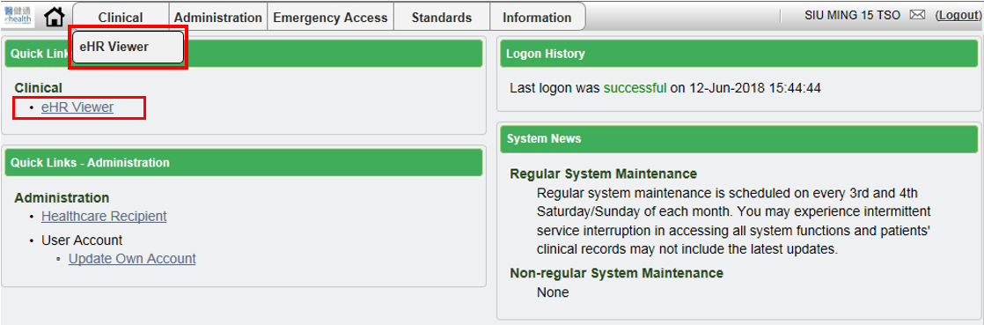

  - For the Observation Record, EVE will display three detailed pages, which include Blood Pressure/Pulse, Blood Glucose and Body Measurement.
In the Tree:
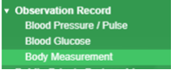

Blood Pressure/Pulse
- Recent Record View
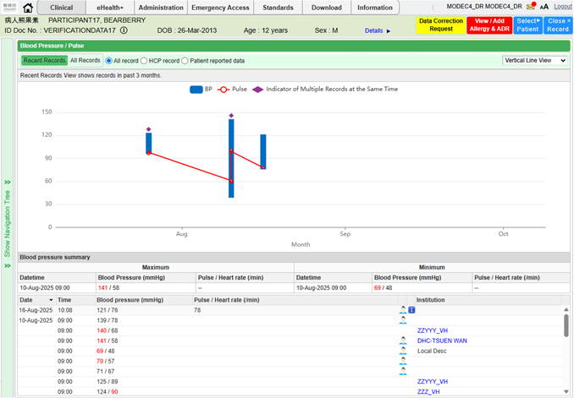

- All Record View
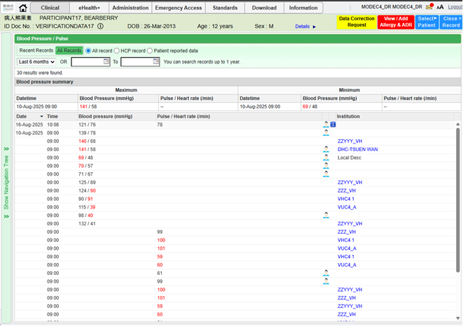

Blood Glucose
- Recent Record View
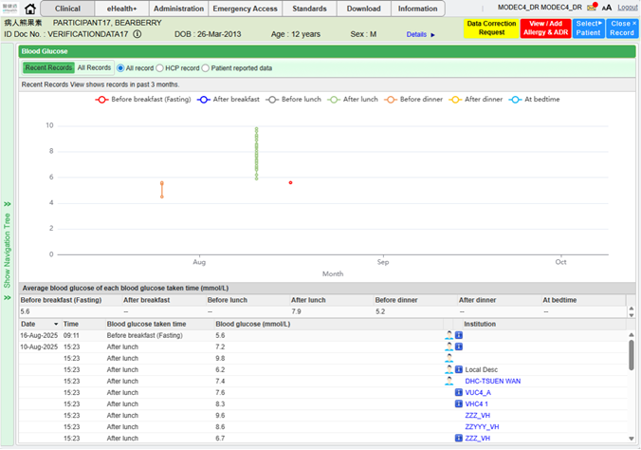

- All Record View
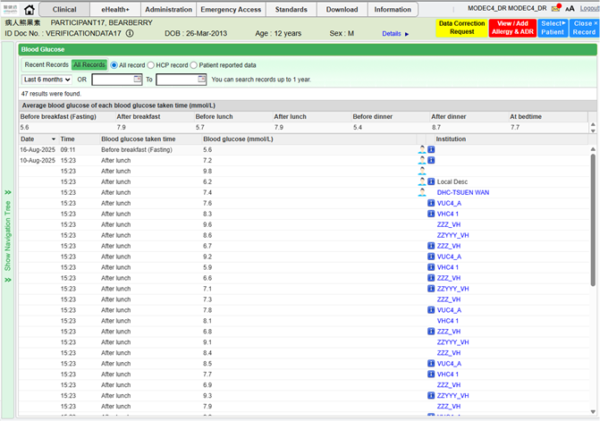
Body Measurement
- Recent Record View
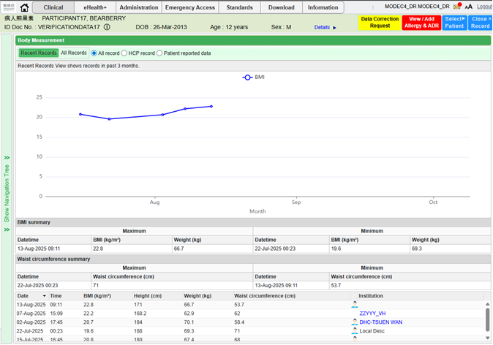

- All Record View
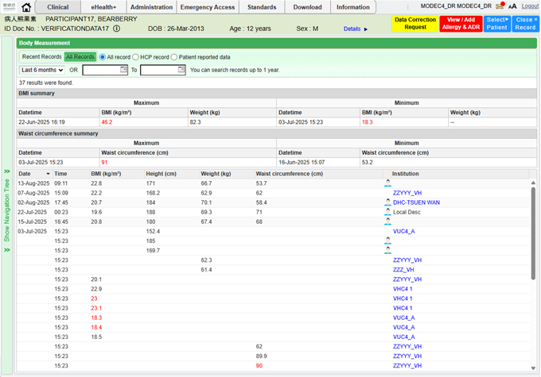

Appendix – Actual Data Values (Sample)

If the actual values entered are various from the test case, please provide actual values as below.
If the value is not inputted, please use [BLANK] to indicate that empty value is inputted intentionally.

